## JS Back-End Retake Exam – Wizard Creatures Wiki

## Exam Rules

1. You have **4 hours**
2. When you are ready, delete the ***node_modules***folder, make sure all dependencies are listed in the ***package.json*** file, and submit your archiving project.
3. You are provided with **HTML & CSS** resources.
4. You may **add attributes** (such as **class** and **dataset**), but it is forbidden to **change** **existing** attributes (such as **class** and **id**).
5. You may **change "href"** attributes on links and add/change the **method** and **action** attributes of HTML forms.
6. Use **Express.js** as a back-end framework.
7. Use **MongoDB** as a database with [**mongoose**](https://mongoosejs.com/docs/).
8. You can use whatever **view engine** you like ([**express-handlebars**](https://www.npmjs.com/package/express-handlebars), EJS, Pug, etc.).
9. Use [**bcrypt**](https://www.npmjs.com/package/bcrypt) **for hashing the password**.
10. The application **must start** from the file ***index.js*** on port **3000**.
11. It is **forbidden** to **use** **React**, **Vue**, **Angular,** etc.
12. **Only the last submission will be evaluated!**

## Application Overview

Get acquainted with the provided **HTML and CSS** and create an application for **creatures in wizard world.**

The visitors can **view** the **home page** and **all posts** page with available creatures. They can also **register** with an **email**, **first name, last name** and **password**. After registering, they will be able to create their **posts** and **voted to other's posts they are interested in** (if the **current user** is **not** the author of the post). Authors can edit or delete posts at any time.

## Functional Requirements

### Guest (Not Logged-in)

**Guest** navigation example:



The **application** should provide guest (not logged in) users with the functionality to home, all posts, **login,** register, and **details** page.

### User (Logged-in)

**User** navigation example:



The **application** should provide **users** (logged-in) with the functionality to:

* **view the home page and all other pages with logged-in navigation;**
* **view all posts page;**
* **create а new post [Create Post];**
* **access the creatures details page [Details];**
* **vote on a post (**if the **current user** is **not** the **owner of the post);**
* **delete or edit the post depending on the user's authentication (only for the owner of the current post).**

## Database Models

The **database** of the **Wizard-Creatures-Wiki** application needs to support **two entities**:

### User

* firstName – string (required)
* lastName – string (required)
* email – string (required)
* password – string (required)

### Creature

* **name – string (required)**
* **species – string (required)**
* **skinColor – string (required)**
* **eyeColor – string (required)**
* **image - string (required)**
* **description – string (required)**
* **votes – an array of objects containing the users' ID**
* **owner – object ID (a reference to the User model)**

**Note:** When a user **votes for creatures**, their **ID** is added to that collection (**voted**)

Implement the entities with the correct data types.

## Application Pages (80 Pts)

#### Home Page (Logged-in Users and Logged-out Users)

Visualize **static home page:**

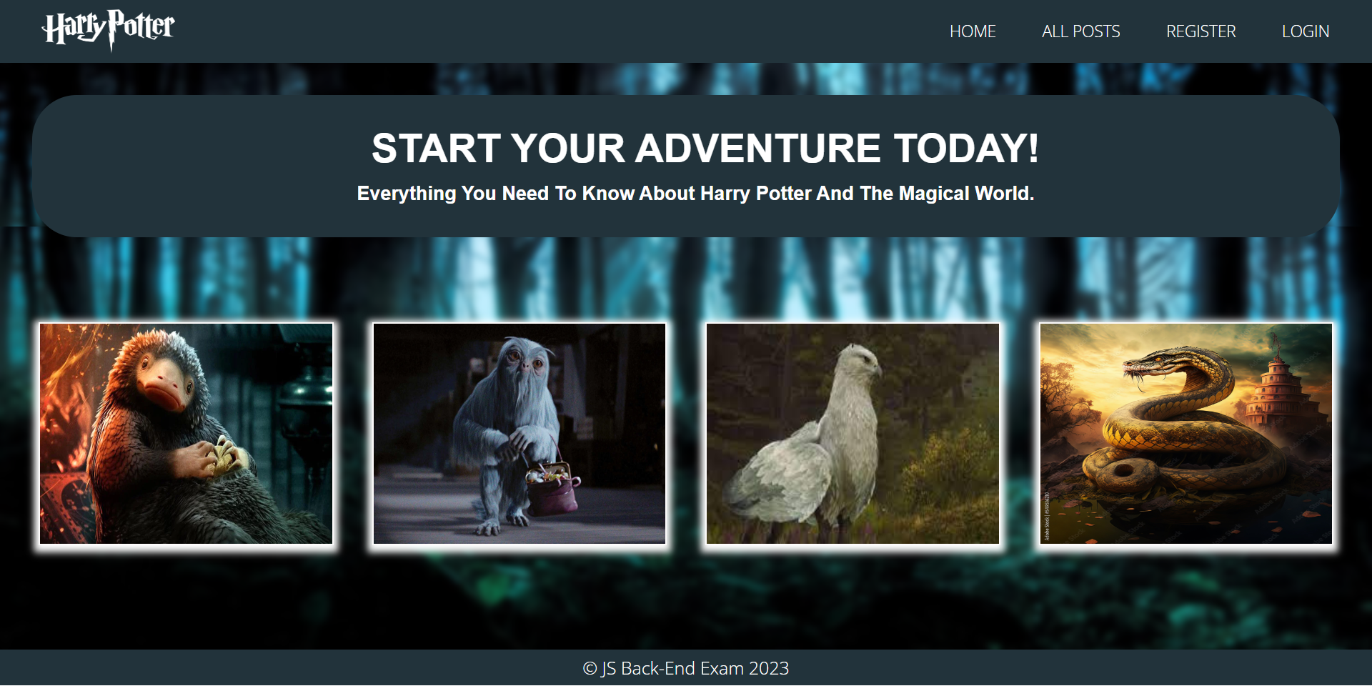

#### Register Page (Logged-out Users)

**Register** a user inside the database with a **first name, last name, email, and password**. The **password** inside the **database** must be hashed (**use bcrypt**) and both passwords **must match**! After successful registration, the user should log in automatically **and be redirected** to the **home page**.

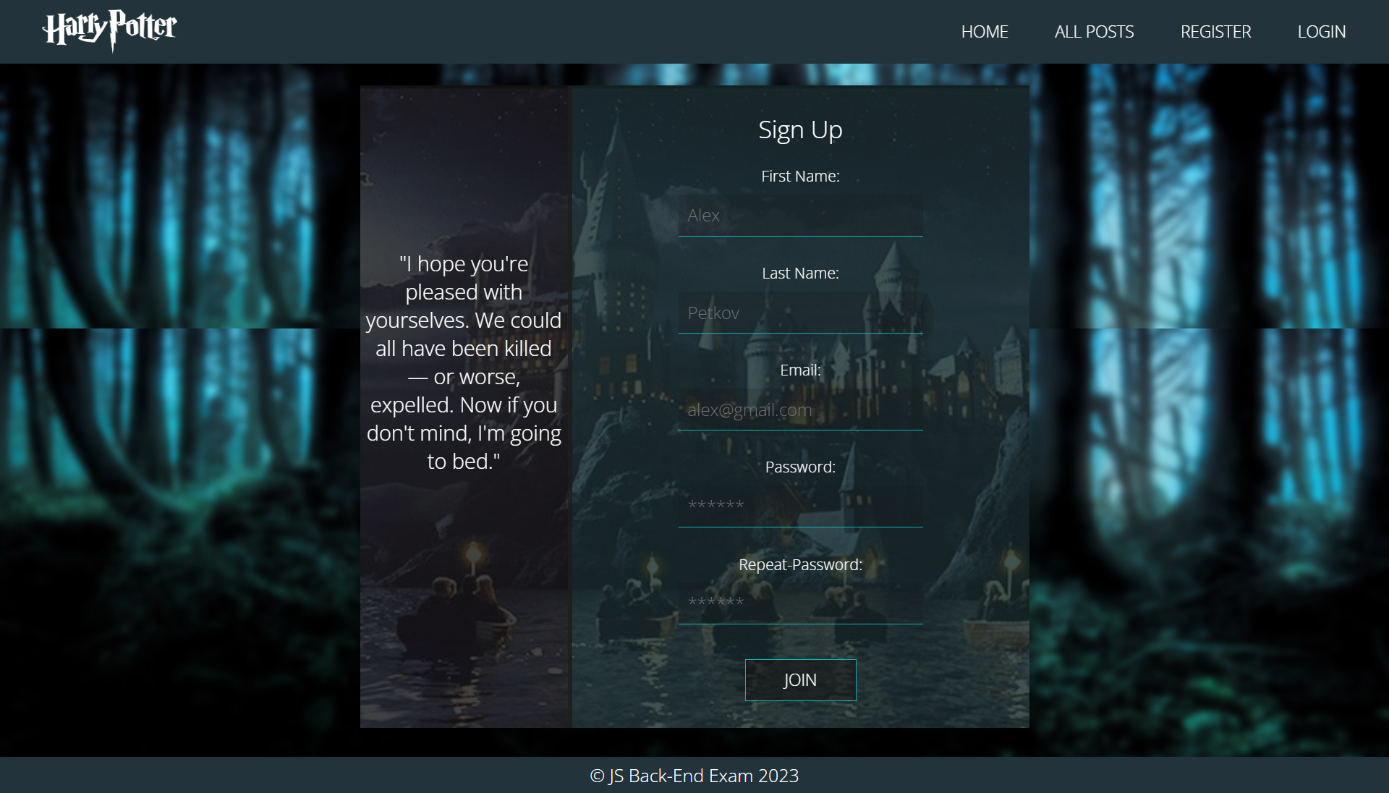

#### Login Page (Logged-out Users)

An already registered user can log in with the correct **email** and **password**. After a successful login, you should **redirect the user to the home page.**

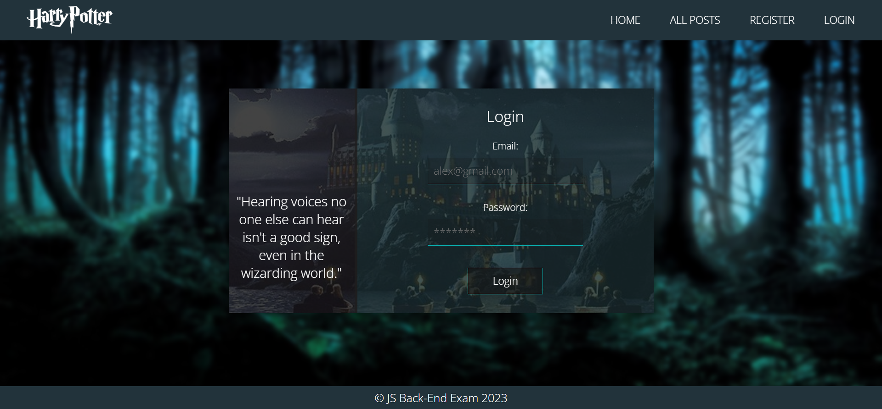

#### Logout (Logged-in Users)

The logout action is available to **logged-in** users. Upon success, clear any session information and **redirect** the user to the **home** page.

#### All Posts (Logged-in Users and Logged-out Users)

List of all creature posts. Each post must display information about the **creature's image**, **name**, **species,** **description,** and a button for **details** about the **specific creature**. As in the picture below:

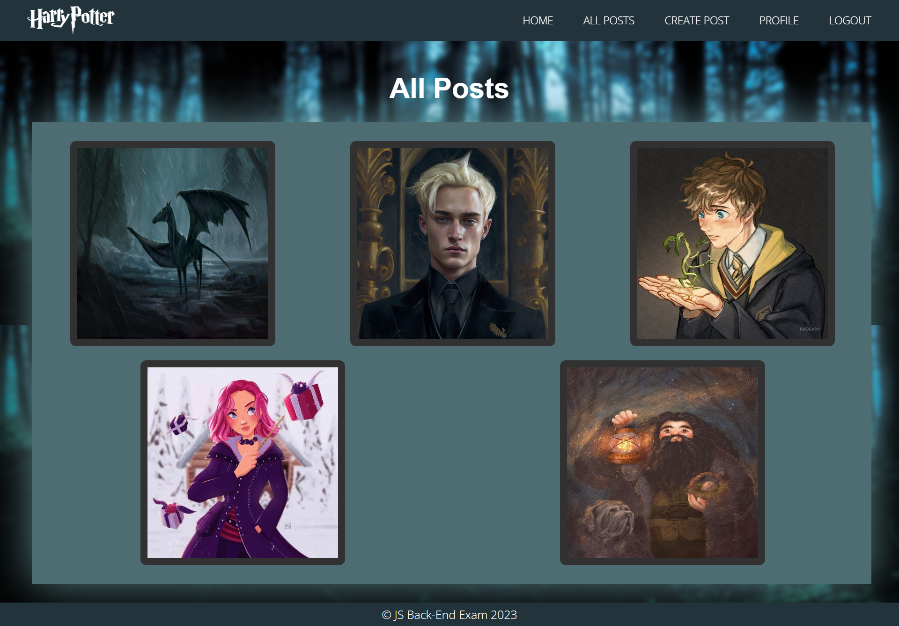

The [**Details**] button should be a link to the **details** **page** for the current creature post.

If there are **NO** creatures in the database yet, display **"There are no posts yet..."**.

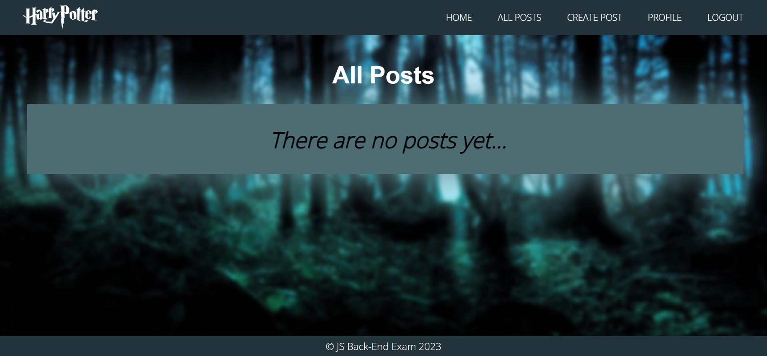

#### Details Page (Logged-in Users and Logged-out Users)

All users should be able **to see details**. Clicking the **[Details]** on the postcard should display the details page. If the currently registered user **is the creator** of the creature's post, the **[Edit]** and **[Delete]** buttons should be displayed. Otherwise, they **should not be available**. Information about the photo:

* **name**
* **author**
* **species**
* **skin color**
* **eye color**
* **description**
* **image**
* **buttons** (depending on the status of the currently logged in user)
* **Votes for this post** 
  + Total rating of votes
  + If there are people who voted, separate their emails with **comma** and **space ", "**
  + If not, display **"No one has voted yet".**

#### Details Page (Logged-out Users)

If the user hasn't logged in, **no buttons** should be displayed.

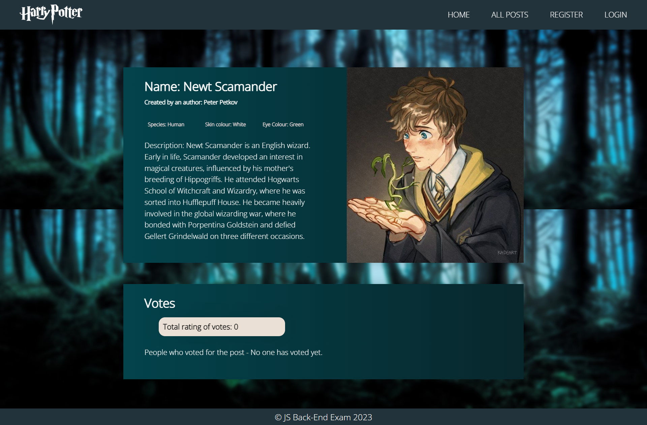

#### Details Page (Logged-in User and Creator of the Current Animal Post)

If the **currently logged-in** user is the **owner** (the user who **created the creature post**), they should see the **[Delete]** and **[Edit]** buttons.

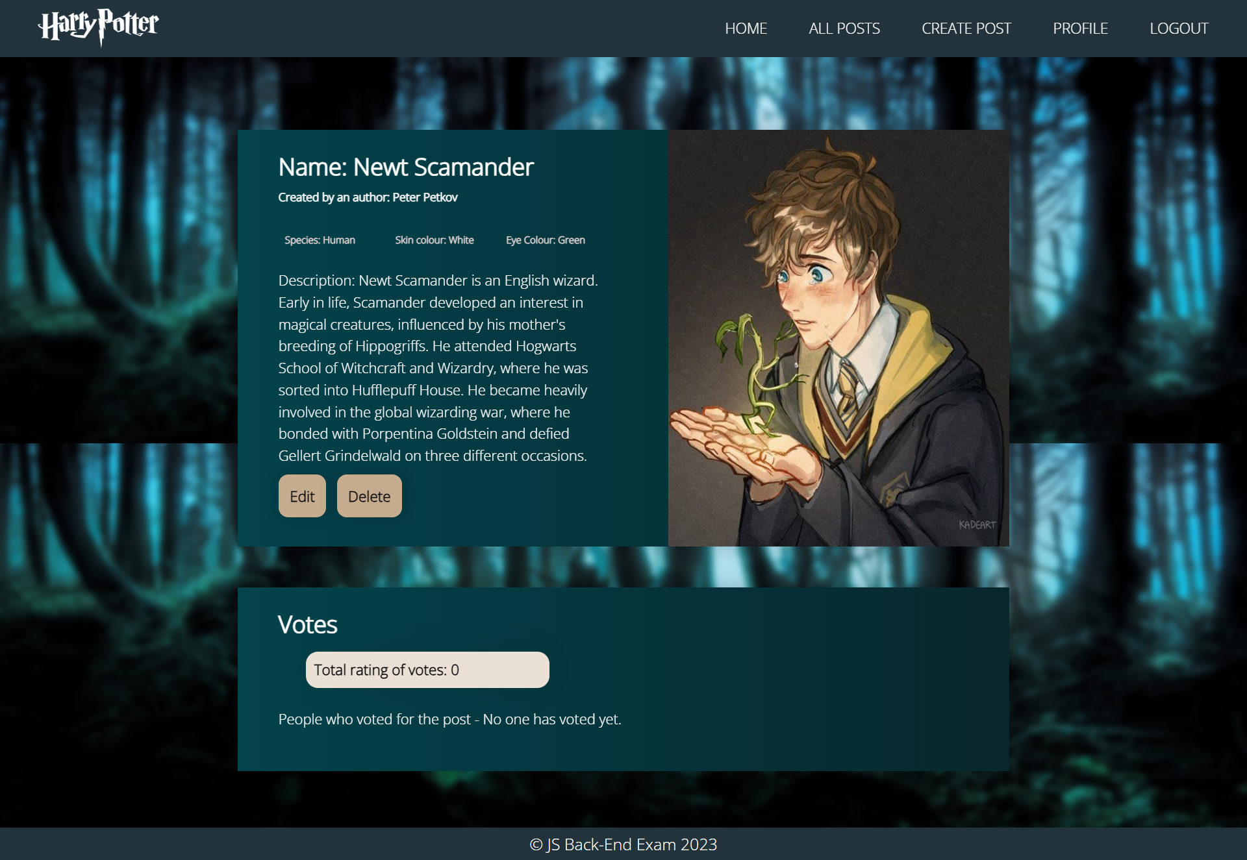

#### Details Page (Logged-in User Who is Not the Current Post Owner)

If the currently logged-in user is **not the owner** (the creator of this post), he/she should see **the vote button.**

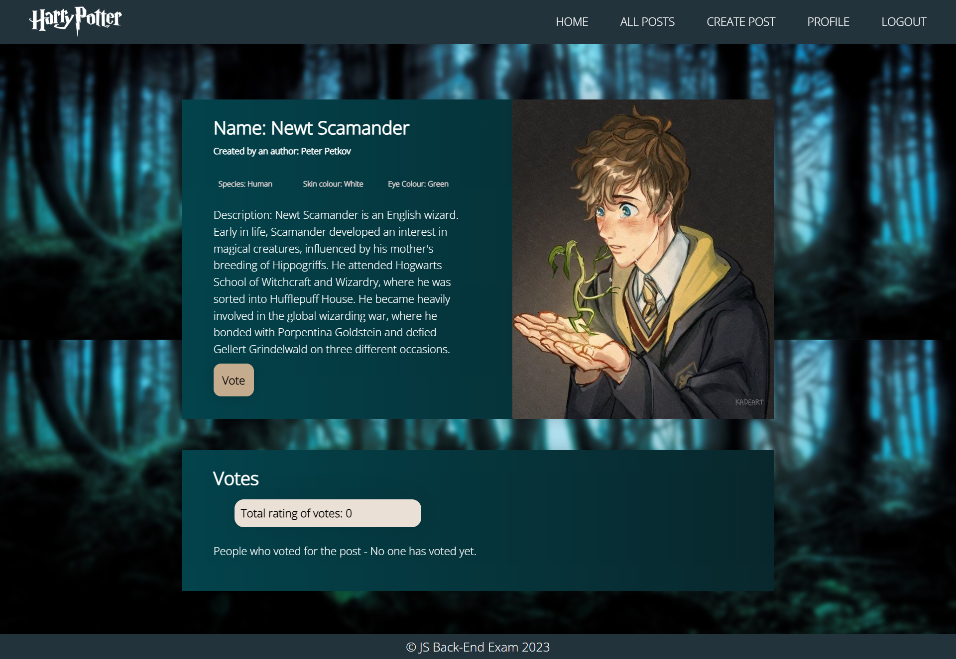

#### Vote (Logged-in User Who is Not the Current Post Owner)

Any registered user who is **not** the **owner** of the current post should be able **to vote**.

When he or she **click on [Vote]**, his/her **user ID** should be added to the **"voted"** collection the post and the user should be **redirected** to the **details** page for the current **creature post**.

In the list- **People who voted for the post**, the **emails** of the people who voted must be displayed.

If a user has once voted on the post, he should see "**Thanks For Voting**" and in the list- **People who voted for the post**, his email should be displayed.

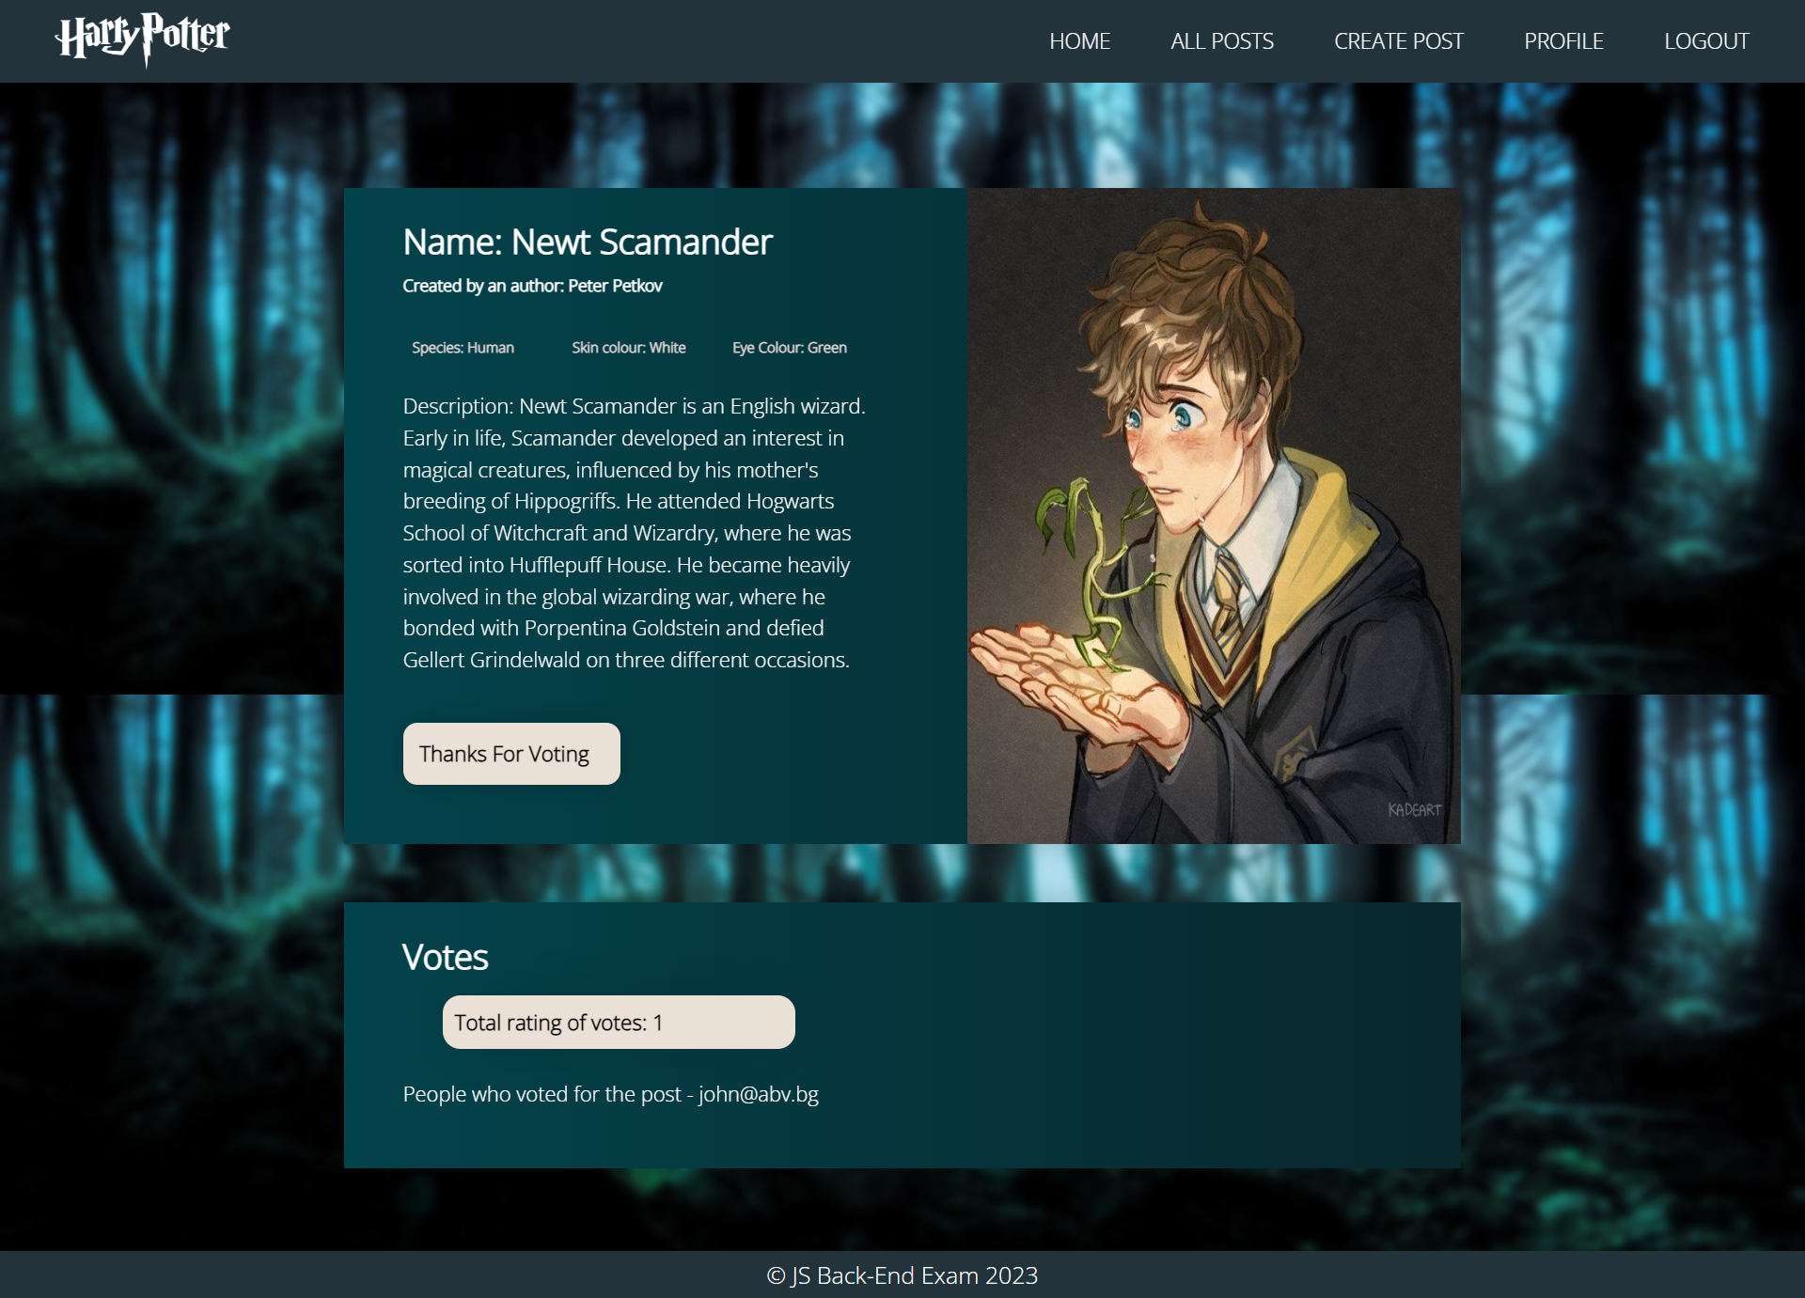

#### Add Creature (Logged-in User)

The **create** page is available to **logged-in users**. It contains a form for adding a new creature post. Upon success, **redirect** the user to the **all-posts** page.

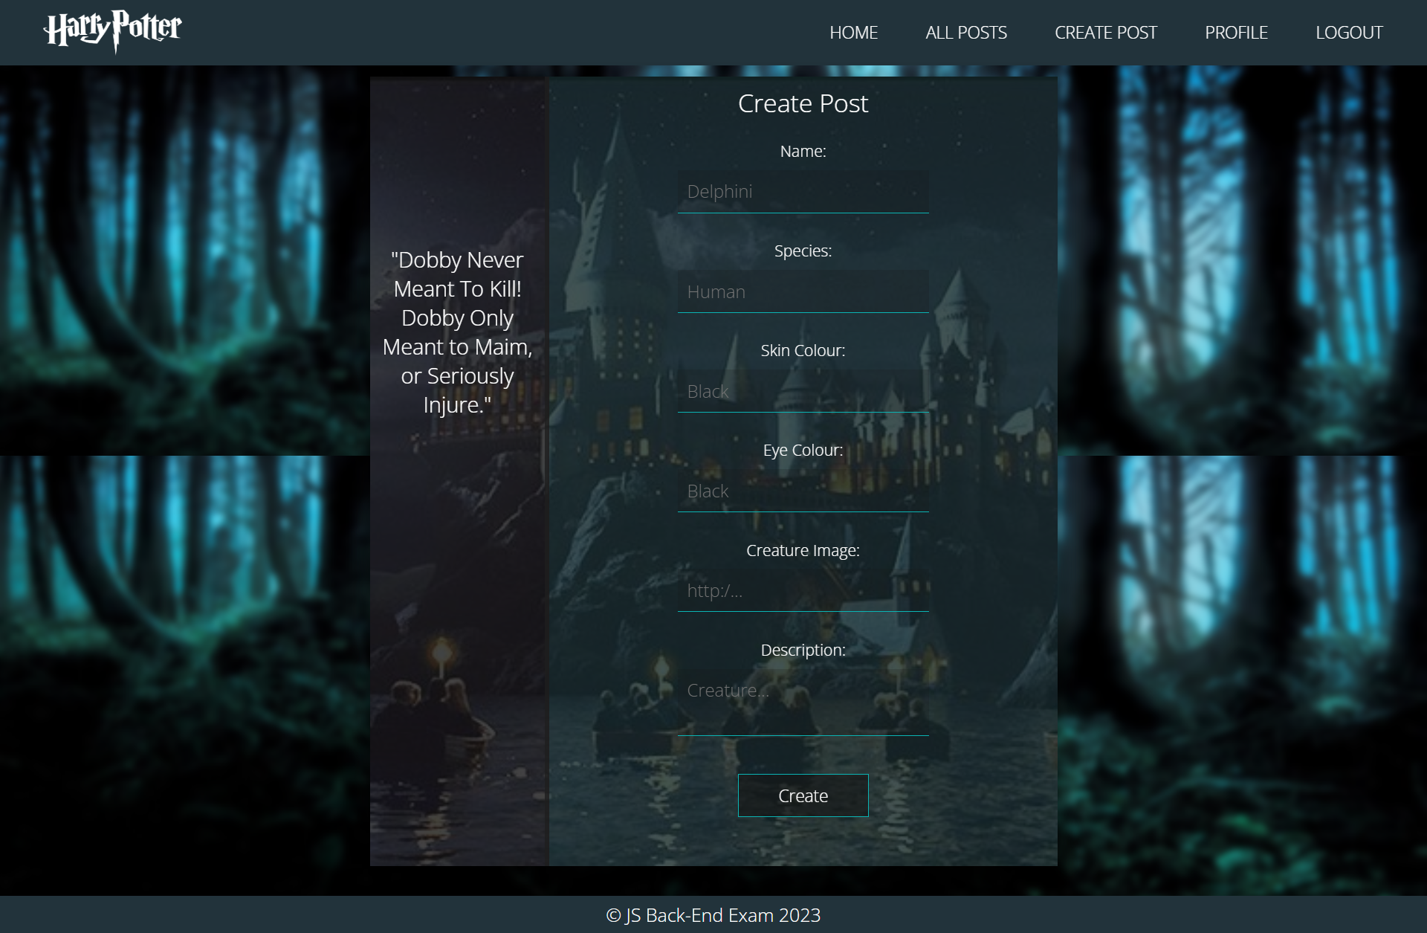

#### Delete Creature (Logged-in User and Owner of the Current Post)

Each creature post **owner** should be able to click on the **[Delete]** button and **delete the current post** from the database. After that, they should be redirected to the **all-posts** page.

#### Edit Creature (Logged-in User and Owner of the Current Post)

Each **user** can edit their **creature posts**. Clicking the **[Edit]** button for a specific post on the details page should display the **edit page**, all fields being populated with the creature data. The page contains a form with input fields for all relevant properties. If **successful**, redirect the user to the **current creature post details page**.

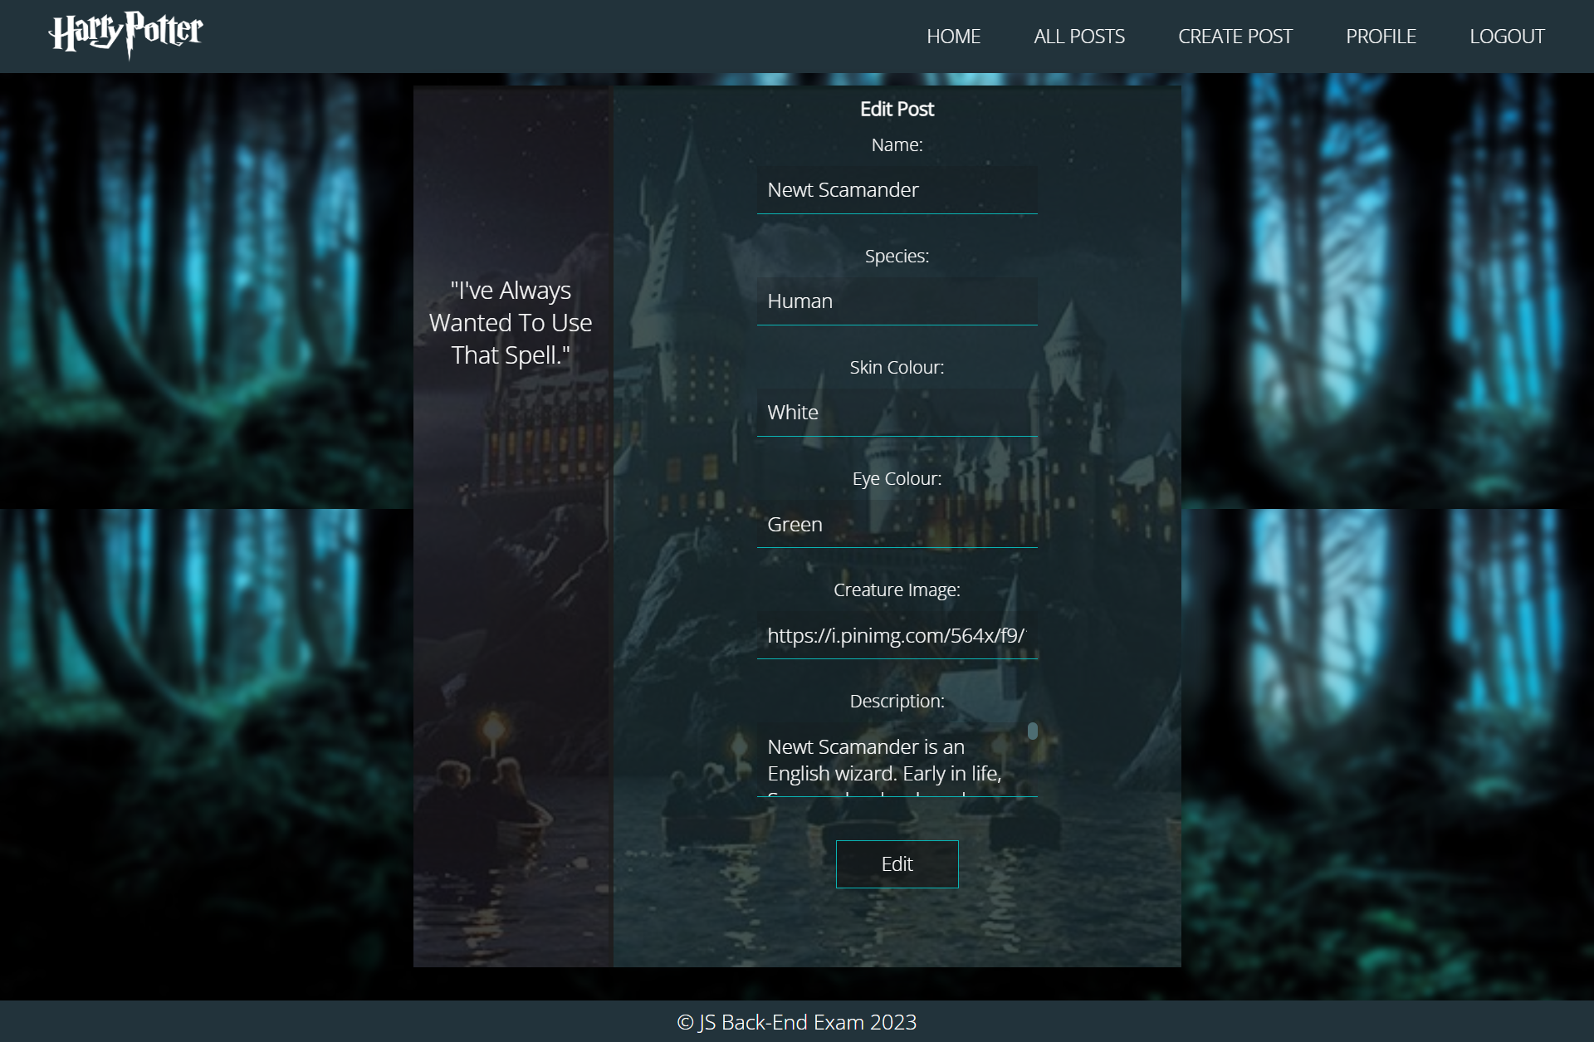

## Security Requirements / Routes Guards (10 Pts)

The security requirements are mainly **access** requirements, i.e., configurations specifying which users can access specific functionalities and pages.

* Guest (not logged-in) users can access the home page.
* Guest (not logged-in) users can access the login page and functionality.
* Guest (not logged-in) users can access the register page and functionality.
* Guest (not logged-in) and users (logged-in) can access the **all posts** (a list of all creature posts).
* Guest (not logged-in) can access the **details** page without functionality.
* Users (logged-in) can access the home page.
* Users (logged-in) can access the details page and functionality.
  + **Users** (not creature post owners) can **voted for post**.
  + **Users** (creature post owners) can **edit** and **delete** their creature posts.
* Users (logged-in) can access the **profile** page and functionality.
* Users (logged-in) can access the **create post** page and functionality.
* Users (logged-in) can access the logout functionality.

Use the following view for **invalid** **paths**:

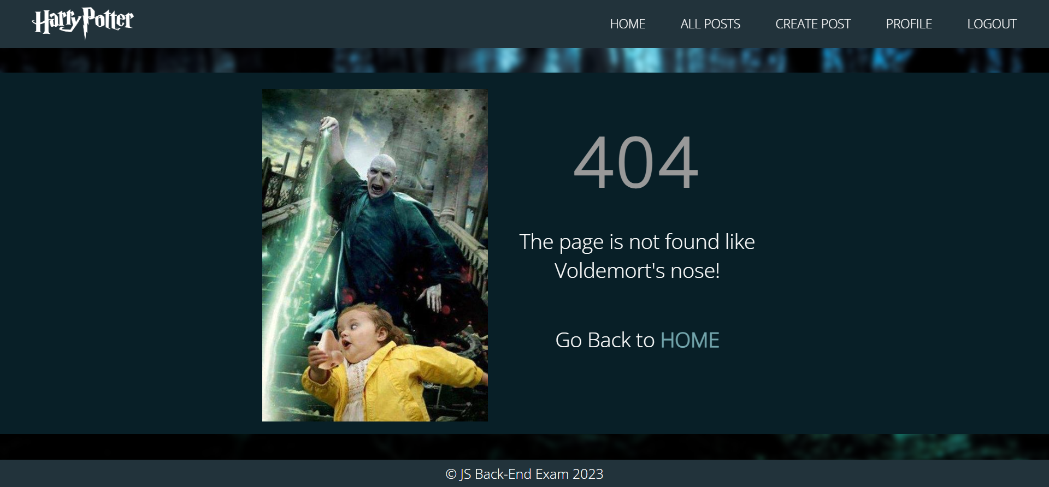

## Validation and Error Handling (10 Pts)

### The application should notify the users about the result of their actions.

In case of an error, you should display a <div> with the class "**error-container**".

### You can choose to display the first error or all of them. You have complete freedom to choose the content of the error message you will display.

### Login / Register

You should make the following validations:

* The **first name** is required and should be **at least 3 characters** long.
* The l**ast name** is required and should be **at least 3 characters** long.
* The **email** is required and should be **at least 10 characters** long.
* The **password** is required and should be **at least 4 characters** long.
* The **repeat password** is required and should be **equal to the password**.

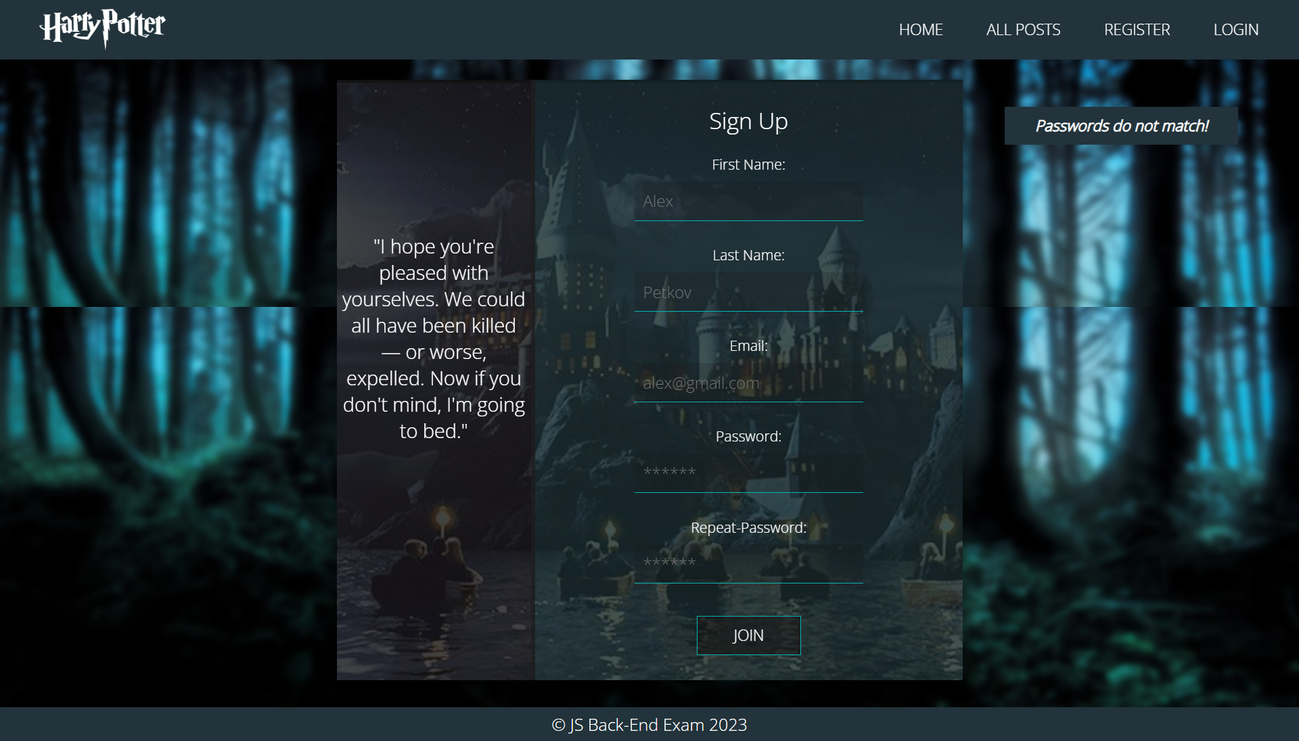

### Animals

You should make the following validations while **creating** or **editing an animal** **post**:

* The **name** is required and should be **at least 2 characters**.
* The **species** is required and should be **at least 3 characters.**
* The **creature image** is required and should start with **http:// or https://**
* The **skin color** is required andshould be **at least 3 characters.**
* The **eye color** is required and should be **a at least** **3 characters.**
* The **description** is required and should be at least **5 and no longer than 500 characters**.

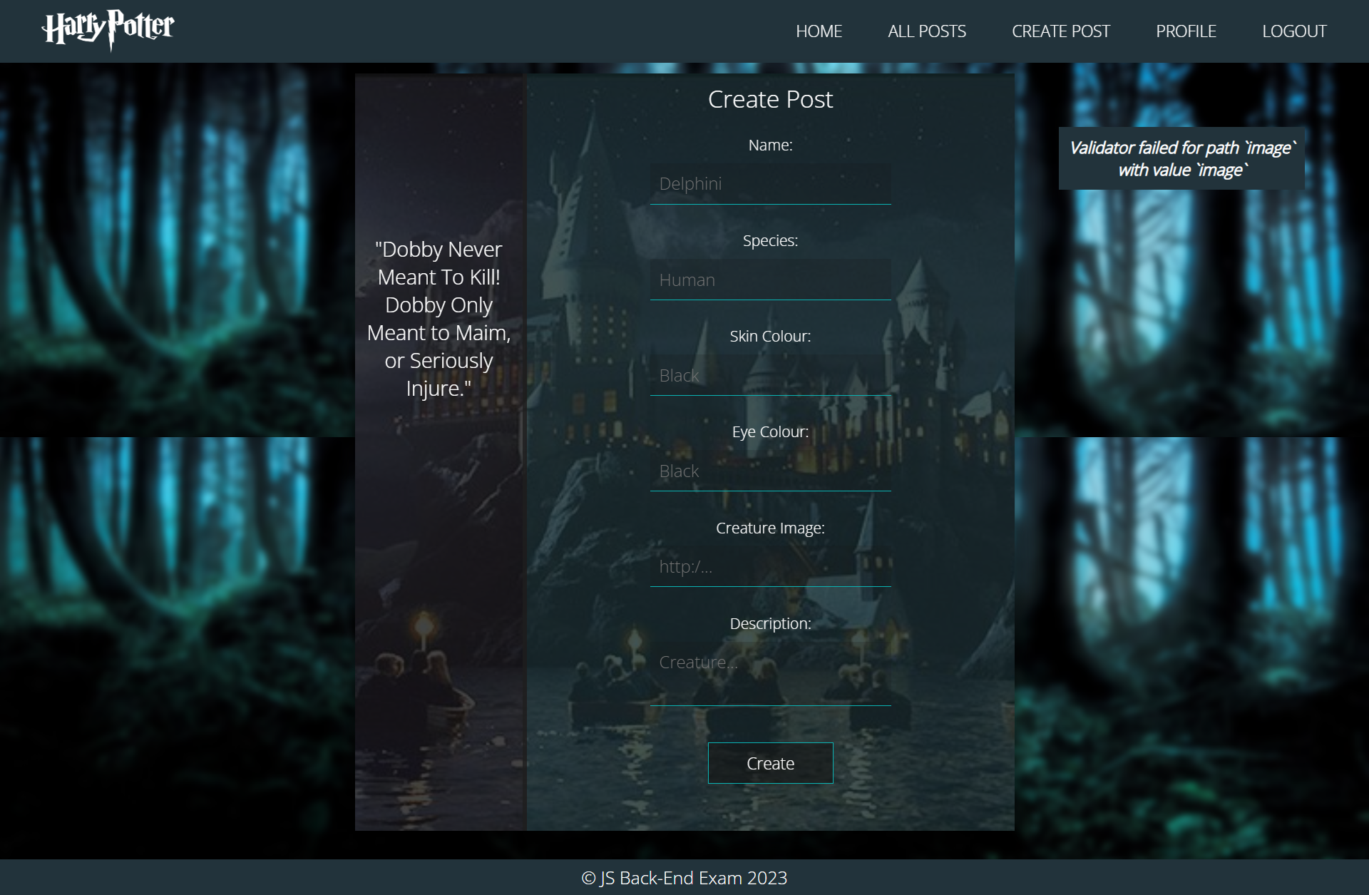

## * Bonus – Profile (10 Pts)

Each **logged-in** **user** should be able to view their profile information by clicking [**Profile**].

Each post must display information about the **creature's image**, **name**, **species,** **author, rating of votes,** and a button for **details** about the **specific creature**. As in the picture below:

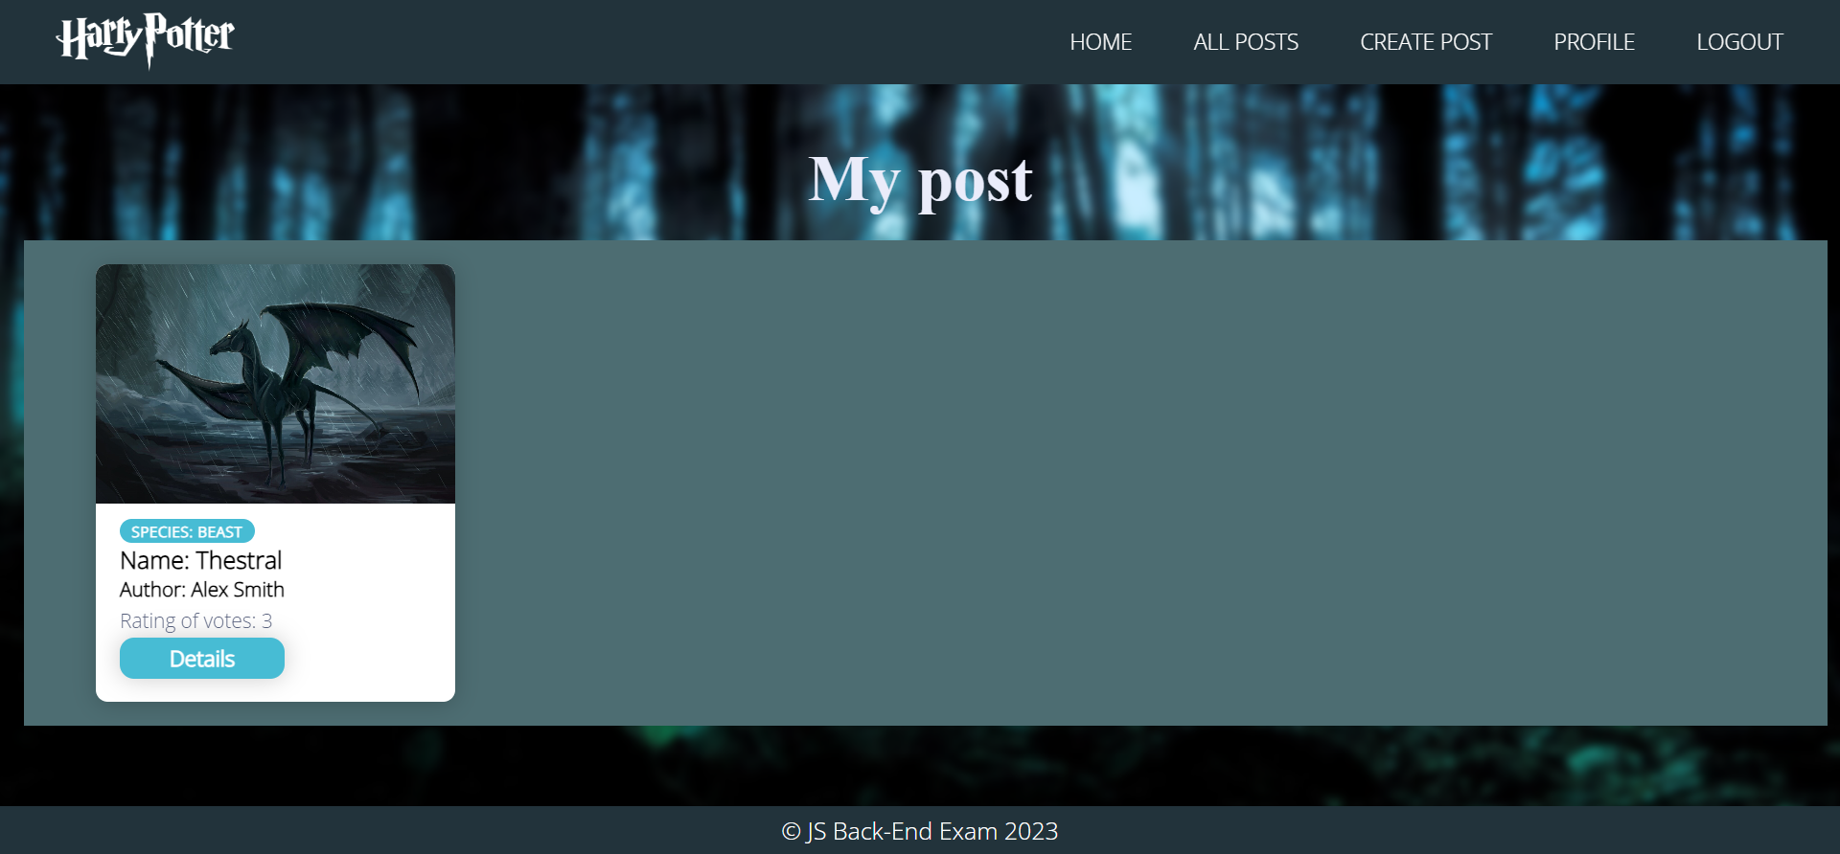

If there are **no** posts, display: 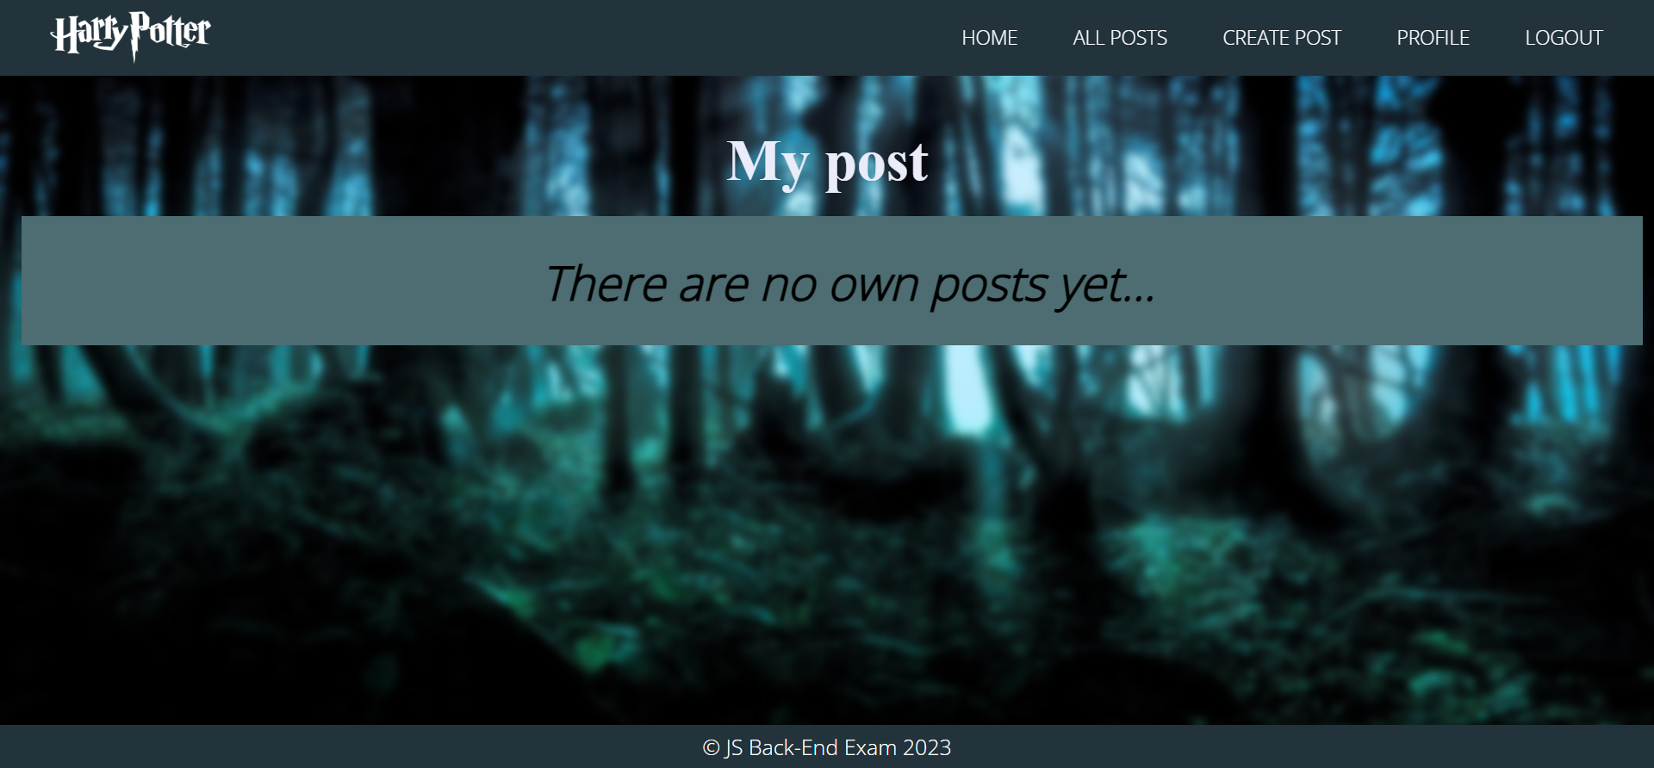

## Submitting Your Solution

Select all files and folders in your project folder. Exclude the *node_modules* folder. Compress the selected files and folders into **a zipped archive folder**. Upload the archive in the softuni learning system: <https://softuni.bg/trainings/4111/js-back-end-may-2023#lesson-54980>



*GOOD LUCK! 😊*